Indian Political, Economic and Sociological Thoughts

MCKS Sem 1 Course 2 Notes

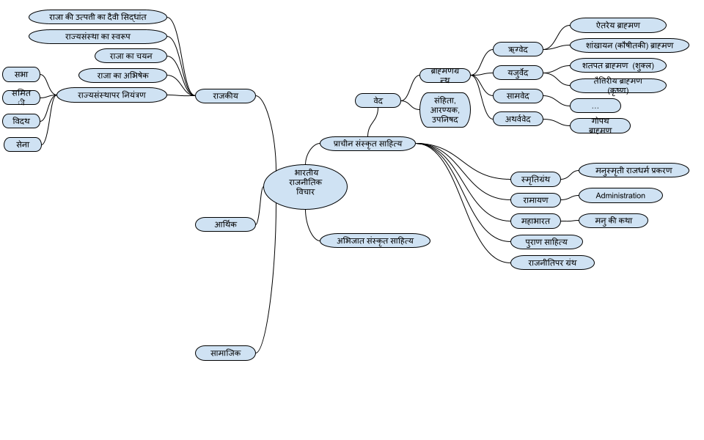

## **राजकीय**

### राजा की उत्पत्ती का दैवी सिद्धांत

Someone from the group, can be vaidya, purohit, mantrik

Like gruhapati of family, he has authority to command, penalize, and sell people; same got extended to 'kul', then to 'sangh' then to state.

ऋग्वेद:

कुटुम्ब -> जन्मन्/कुल -> विश -> जन

विश most powerful group, had own army, leader is called विश्पति

जन - many विश , leader जनपति

### राज्यसंस्था का स्वरूप

3 groups

ब्रह्म : पुरोहित, यज्ञ की जिम्मेदारी

क्षत्र: युद्ध नेतृत्व , समाज में अनुशासन

विश : सर्वसाधारण लोग

raja gets selected from good family of क्षत्र

### राजा का अभिषेक

* At that time, he used to say "in my kingdom all trees, humans, should be free from disease, disasters. Public should be free from fear and destruction"
* This ceremony was done by purohit, that is why Purohit became important

### राजा का चयन

From common people directly or via कुलपति / विश्पति

### राज्यसंस्थापर नियंत्रण

#### सभा

* A group of people (elder / learned) chosen by the common people of the village
* People coming together and discussing for arriving at a favorable decision.
* Sister of Samiti.
* Prayer: May all those that sit assembled in you, utter speech in harmony with me.

#### समिती

* Group of people at the capital of the Kingdom.
* सम्+इति । Meeting together – Assembly of commoners. Chief is called ईशान
* Functions: - election of king, discuss matters of state. King used to attend the Samiti and it was necessary for him to do so. people were anxious to make
* speeches agreeable to the assembled ones

#### विदथ

The religious life was organized through Vidatha. It is the parent folk-assembly from which Samiti, Sabha and Sena differentiated.

#### सेना

Army – A constitutional unit.

## प्राचीन संस्कृत साहित्य

## वेद

#### ऋग्वेद

raja means leader of a group, purohit is also important. Raja selected or elected

### रामायण

Part of Ayodhya Kanda (Sarga 100)

* Almost every verse contains the word – कच्चित् – hence called as Kaccid Sarga
* Rama’s advice to Bharata as regards to the duties of a king and polity under an ideal monarchy.
* When Rama went for exile and Bharata came to know about it, he followed Rama along with his paraphernalia to bring his elder brother back to the throne.
* This conversation takes place in the forest.
* I hope that ministers who are valiant like you, learned, masters of their senses of noble birth and skilled interpreting internal sentiments by external gesture, are assigned to you.
* I hope that you do not deliberate alone nor indeed with numerous men. I hope your decision
* arrived at by you through such deliberation does not flow to the public (even before it is carried out)

### महाभारत

#### मनु की कथा

No king, no penalties, dharma deteriorated, few wise went to brahmadev, he asked Manu to be king, he refused, people negotiated that he won’t be responsible for their sins, will get tax, he agreed.